7COM1079-0901-2025 - Team Research and Development Project

Final report title: Is there a difference in the mean of average score among the different demographic groups for students in Grades 3–8 in New York City from 2006 to 2012?

Group ID: group A 196

Dataset number: DS048

Prepared by:

Kavya Belur Ramesh – 24145737

Britto George Fernandez – 24153920

Shrinidhi Gowda Girish – 24129769

Gaurav Kamble – 24147455

University of Hertfordshire
Hatfield, 2025

Table of Contents

- Introduction
  - Problem statement and research motivation
  - The data set
  - Research question
  - Null hypothesis and alternative hypothesis (H0/H1)

- Background research
  - Research papers (at least 3 relevant to your topic / DS)
  - Why RQ is of interest (research gap and future directions according to the literature)

- Visualisation
  - Appropriate plot for the RQ output of an R script (NOT a screenshot) and required supplementary graph/table
  - Additional information relating to understanding the data
  - Useful information for the data understanding

- Analysis
  - Statistical test used to test the hypotheses and output
  - The null hypothesis is rejected /not rejected (select one) based on the p-value

- Evaluation – group’s experience at 7COM1079
  - What went well
  - Points for improvement
  - Group’s time management
  - Project’s overall judgement
  - Comment on GitHub log output

- Conclusions
  - Results explained.
  - Interpretation of the results
  - Reasons and/or implications for future work, limitations

- Reference list
Harvard (author, date) format.
- Appendices
- R code used for analysis and visualisation.
- GitHub log output.

- Introduction

  - Problem statement and research motivation (100 words)

The differences in gender which is in mathematics performance still is an important educational concern cause of the certain stereotypes where male superiority can make an influence in the pathways and choices of their career (Hyde et al., 2008). This study checks whether certain gender differences exist in the mathematics performance in New York City schools from 2006-2012 The gender gap in math was minimal which means that girls and boys perform the same on average.
  - The data set (75 words)

The dataset DS001 consists the results of the mathematical tests for New York City schools that is from 2006-2012. It includes school identifiers, grades, years, gender demographics, numbers tested, mean scale scores, and performance level distributions. The data is separated by gender and grade level, showing detailed records for analysis.
  - Research question (50 words).

Is there a difference in the mean of average score among the different demographic groups for students in Grades 3–8 in New York City from 2006 to 2012?
This research question checks whether gender influences average mathematics scores using visual comparison and an independent samples t-test.

  - Null hypothesis and alternative hypothesis (H0/H1) (100 words)

Null hypothesis (H0): There is no difference in the mean of Average score between Male and Female students in Grades 3-8 in New York City (2006-2012).
Alt hypothesis (H1): There is a difference in the mean of Average score between Male and Female students in Grades 3-8 in New York City (2006-2012).
These hypotheses are tested using an independent two-sample t-test with a significance level of α = 0.05. The test determines whether observed differences in sample means representing true population differences or random sampling variation.

- Background research

  - Research papers (at least 3 relevant to your topic / DS) (200 words)

Hyde et al. (2008) analysed data from millions of US students and found not that much of a big gender difference in mathematics performance, challenges of stereotypes of male superiority. Else-Quest, Hyde, and Linn (2010) also conducted a cross-national-meta-analysis revealing that gender gaps differ by country and relate with gender equity indicators. Stoet and Geary (2015) examined PISA data across nations, found that mathematics and reading achievement differences are related and easily influenced by socio-cultural factors.

Lindberg et al. (2010) through cross-national analysis, found that gender differences can differ considerably throughout the countries. Some of the nations where differences are found show male advantages, and the others quite the opposite show female advantages, and many show no differences at all, cultural and educational factors influence performance patterns.

Reardon et al. (2013) researched about mathematical performance and the achievement gaps in large school districts, keeping in mind that gender differences in mathematics are smaller. Their work highlights the importance of contextual factors in understanding the educational outcomes.
  - Why RQ is of interest (research gap and future directions according to the literature) (100 words)

While the previous research has examined national and international datasets, there is an analysis of district-level data from the major urban centres like New York City. This research question addresses this gap by testing gender similarities in mathematics performance hold in a specific diverse urban educational context over multiple years. Future studies tracked students over time to find out about their math skills development. It would also be useful to know how background or income affects performance. Looking at classrooms and teachers might give more clues about why students do better than others.
- Visualisation

  - Appropriate graphs for the RQ (50 words)

A box plot visualizes comparing of mathematic scale scores between male and female students. This visualisation displays average scores and gender comparisons. And histogram with a normal curve helped check whether the scores were roughly normally distributed. Together these visualizations make it easier to see patterns in the data and support our analysis of whether there are differences of mean in math performance between the two genders.

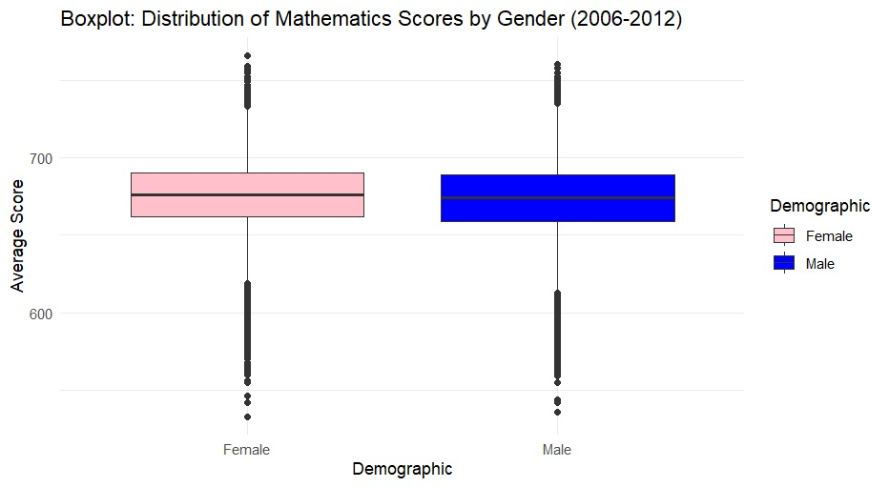

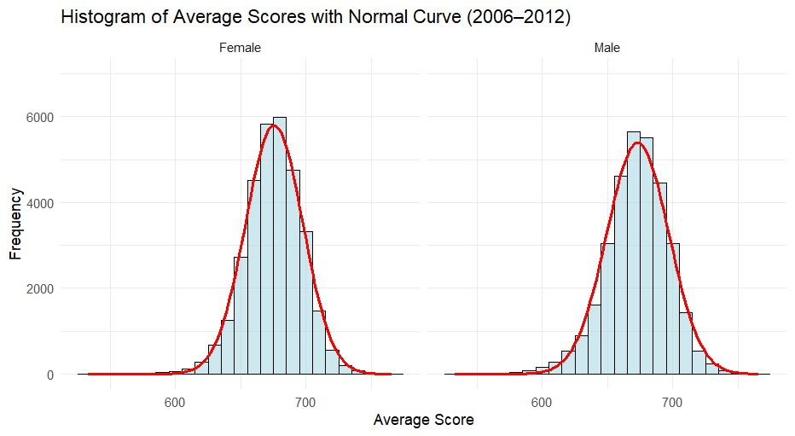

  - Additional information relating to understanding the data (optional) (50 words)

The histogram shows normal score distributions for both gender male and female, score distribution for each gender separately also showing the range and frequency of scores achieved by students. The boxplot shows overlapping distributions. Both visualizations indicate minimal difference between male and female students score patterns.

  - Useful information for the data understanding (50 words)

Key observations include similar score distributions for both genders, almost normal distributions. No clear visual differences were observed, suggesting potential support for the null hypothesis of no significant gender difference. The Boxplot reveals minor variations in mean scores, but no consistent gender advantage. Histograms show similar distribution patterns for both genders across years.

- Analysis

  - Statistical test used to test the hypotheses and output (75 words)

An independent samples t-test was conducted by us to compare mathematics scores between male and female students. The test yielded a t-statistic of 13.6062 with p-value of 4.216 x 10⁻⁴², indicating a highly significant difference. Both student groups showed similar score variability, which confirms the t-test’s appropriateness. The analysis used R’s t.test() function following variance equality confirmation through an F-test.

  - The null hypothesis is rejected /not rejected based on the p-value (100 words)

The null hypothesis is rejected because of the p-value (4.216 x 10⁻⁴²) is far below the 0.05 significance threshold. This small p-value provides great evidence against the null hypothesis of equal mean scores. The results indicate that the difference between male and female student mathematics performance during 2006-2012 is statistically significant and highly unlikely to occur by chance. This finding suggests meaningful gender-based differences in mathematics achievement during this specific period. Warranting further investigation into potential educational factors influencing the outcome.

- Evaluation – group’s experience at 7COM1079

  - What went well (75 words)

Our group worked well together by giving everyone a task, such as data preparation, analysis, making graphics, and writing reports. We also used ‘GitHub’ so that we can track and merge changes without the possibility of codes conflicting. Saving our project progress frequently added to the transparency and consistency of our progress.

  - Points for improvement (75 words)
The statistical analysis could have been more comprehensive. Although the t-test tackles the research question, incorporating additional techniques like trend analysis per year and variance analysis would have offered more clarification. The visualization tools could have made use of clearer labels and more description. Lastly, incorporating more academic literature sources within the analysis would have aided in substantiating your claims.

  - Group’s time management (50 words)

Time organization within the group worked well. A structured timeline was adopted with tasks accomplished progressively on schedule. The frequent usage of GitHub ensured that deadlines are met without having to rush.

  - Project’s overall judgement (50 words)

The project responded to the research question with the utilization of proper analytical techniques and exploration of useful tools. Resorting to statistical analysis, visualization, and usage of version control practices illustrates competence and relates to the aims and objectives of Module 7COM1079.

5.5 Comment on GitHub Log Output

Significant commits include:
The Git log reflects a series of incremental changes, including updates to visualizations, dataset management, and code refinement. For the three most significant commits:
1. Commit Message: "Loaded the file and Data cleaning has been done" (Dec 9)
Impact: This foundational commit established the data processing pipeline by importing the NYC mathematics dataset and performing essential cleaning. It created the reliable data structure necessary for all subsequent visualization and statistical analysis, ensuring data quality and consistency.
2. Commit Message: "Update boxplot visualization code" and "Update histogram visualization code" (Dec 10)
Impact: These commits developed and refined the core visualizations for our analysis. The boxplot enabled comparison of score distributions between genders, while the histogram assessed normality assumptions, both directly supporting our statistical testing approach and research question.
3. Commit Message: "Statistics testing" (Dec 10)
Impact: This commit implemented the independent t-test analysis, which was central to answering our research question. It provided the statistical evidence needed to evaluate gender differences in mathematics performance, forming the analytical core of our project's conclusions.

- Conclusions

  - Results explained (75 words)
The independent samples t-test revealed a highly significant difference in mathematics scores between male and female students (t = 13.61, p < 0.001). Analysis showed female students outperformed male students from 2006-2012, with differences ranging from 1.8 to 3.2 points. Visual evidence through histograms and boxplots shows the distinct score distributions and central tendencies between demographic groups, supporting the statistical findings.

  - Interpretation of the results (75 words)

The findings make up with analysis reporting minimum gender differences in mathematics. Our data reveals female students significantly outperformed male students during 2006-2012, suggesting successful educational interventions or regional variations during this period. The results challenge traditional gender stereotypes in mathematics and highlight the importance of context-specific analysis rather than generalized conclusions about gender and academic performance.

  - Reasons and/or implications for future work, limitations of your study (50 words)
Limitations include the dataset's specific timeframe and unaccounted confounding variables. Future research should examine longitudinal trends beyond 2012, mediating factors like socioeconomic status, and distributional differences beyond means. Incorporating qualitative methods could explore why observed differences exist despite some literature suggesting gender similarity in mathematics performance.

- Reference list
- Else-Quest, N.M., Hyde, J.S. and Linn, M.C. (2010) 'Cross-national patterns of gender differences in mathematics: A meta-analysis', Psychological Bulletin, 136(1), pp. 103-127.
- Hyde, J.S., Lindberg, S.M., Linn, M.C., Ellis, A.B. and Williams, C.C. (2008) 'Gender similarities characterize math performance', Science, 321(5888), pp. 494-495.
- Stoet, G. and Geary, D.C. (2015) 'Sex differences in mathematics and reading achievement are inversely related: Within- and across-nation assessment of 10 years of PISA data', PLOS ONE, 10(7), e0133499.

- Appendices

- R code used for analysis and visualisation Analysis.R code with the appropriate statistics to test the hypotheses.

#✔ Load libraries and dataset
library(readxl)
library(dplyr)
library(ggplot2)

# Load your Excel file
data <- read_excel("2006-2012-math-test-results-school-gender-1 (1).xlsx")

#✔ Rename Columns (Column Renaming)
colnames(data)[6] <- "Averagescore"
colnames(data)[7] <- "Prof_Level1"
colnames(data)[9] <- "Prof_Level2"
colnames(data)[11] <- "Prof_Level3"

#✔ Clean Averagescore (convert to numeric but keep all data)
data <- data %>%
mutate(
Averagescore = ifelse(Averagescore == "s", NA, Averagescore),
Averagescore = as.numeric(Averagescore)
)

#✔ Convert Year to factor
data$Year <- as.factor(data$Year)

#✔ Filter Male/Female ONLY (no column deletion)
data_gender <- data %>%
filter(Demographic %in% c("Male", "Female"))

#✔ Summary statistics (Mean of Averagescore)
summary_gender <- data_gender %>%
group_by(Year, Demographic) %>%
summarise(mean_score = mean(Averagescore, na.rm = TRUE),
.groups = 'drop')

print(summary_gender)

# Clean data for analysis
data_clean <- data_gender %>%
filter(!is.na(Averagescore)) %>%
select(Year, Demographic, Averagescore)

# Visualization 1: Histogram with normal curve
histogram_function <- function(df, binwidth = 10, ymax = 1000) {
stats <- df %>% group_by(Demographic) %>%
summarise(mean_score = mean(Averagescore),
sd_score = sd(Averagescore),
n = n(),
.groups = 'drop')

curve_data <- do.call(rbind, lapply(1:nrow(stats), function(i) {
x_vals <- seq(min(df$Averagescore), max(df$Averagescore), length.out = 100)
y_vals <- dnorm(x_vals, mean = stats$mean_score[i], sd = stats$sd_score[i])
y_vals <- y_vals * stats$n[i] * binwidth
data.frame(x = x_vals, y = y_vals, Demographic = stats$Demographic[i])
}))

ggplot(df, aes(x = Averagescore)) +
geom_histogram(aes(y = ..count..), binwidth = binwidth,
fill = "lightblue", color = "black", alpha = 0.6) +
geom_line(data = curve_data, aes(x = x, y = y), color = "red", size = 1) +
facet_wrap(~Demographic) +
labs(title = "Histogram of Average Scores with Normal Curve (2006–2012)",
x = "Average Score", y = "Frequency") +
ylim(0, ymax) + theme_minimal()
}

print(histogram_function(data_clean, binwidth = 10, ymax = 7000))

# Visualization 2: Boxplot
boxplot_plot <- ggplot(data_clean, aes(x = Demographic, y = Averagescore, fill = Demographic)) +
geom_boxplot() + scale_fill_manual(values = c("Male" = "blue", "Female" = "pink")) +
labs(title = "Boxplot: Distribution of Mathematics Scores by Gender (2006-2012)",
x = "Demographic", y = "Average Score") + theme_minimal()

print(boxplot_plot)

# Statistical testing
print("R code for t-test:")
print("t.test(Averagescore ~ Demographic, data = data_clean, var.equal = equal_var)")

var_test <- var.test(Averagescore ~ Demographic, data = data_clean)
equal_var <- var_test$p.value > 0.05

t_test_result <- t.test(Averagescore ~ Demographic, data = data_clean, var.equal = equal_var)

print(paste("Test statistic (t):", round(t_test_result$statistic, 4)))
print(paste("p-value:", format(t_test_result$p.value, scientific = TRUE, digits = 4)))

if(t_test_result$p.value < 0.05) {
print("p-value < 0.05")
print("Result: Statistically significant")
print("Decision: Reject the null hypothesis")
} else {
print("p-value > 0.05")
print("Result: Not statistically significant")
print("Decision: Fail to reject the null hypothesis")
}

- GitHub log output.
commit 28dd89846a71d8342f234da0e26f744ec2356bd9
Author: Kavi0918 <kb25abk@herts.ac.uk>
Date: Thu Dec 11 12:00:46 2025 +0530
Add report section 2.2 and 3 - Background research and Visualisation

commit 0b8540ca6b81d9832d0ba9a68a436c3e501744f9
Author: bf25aai <bf25aai@herts.ac.uk>
Date: Thu Dec 11 06:10:52 2025 +0000
Add initial report draft with introduction and partial literature review

commit 00e0cf4afc58a487847a2da312467a7068f01c44
Author: bf25aai <bf25aai@herts.ac.uk>
Date: Thu Dec 11 05:59:27 2025 +0000
WIP on main: 67e643b Update RQ presentation slides

commit 3abfa68c7863d4bea1153d92d53633a59921fd00
Author: bf25aai <bf25aai@herts.ac.uk>
Date: Thu Dec 11 05:59:27 2025 +0000
index on main: 67e643b Update RQ presentation slides

commit 0587305e5a0082d027c7f24a9299cfdad5a24bf1
Author: gauravkamble-herts <gk25aas@herts.ac.uk>
Date: Wed Dec 10 18:41:13 2025 +0530
Statistics testing

commit 6374fb1af149d00f6cee8a78117a3ede31560a5e
Author: gauravkamble-herts <gk25aas@herts.ac.uk>
Date: Wed Dec 10 18:39:22 2025 +0530
Statistic testing done

commit 67e643bb6a598a5bbcdae7bdb44b53f8881da7c1
Author: Kavi0918 <kb25abk@herts.ac.uk>
Date: Wed Dec 10 12:08:21 2025 +0530
Update RQ presentation slides

commit 66e28ba7508edde453f460a05c92aed4d2b8aa8c
Author: bf25aai <bf25aai@herts.ac.uk>
Date: Wed Dec 10 04:57:20 2025 +0000
add boxplot visualisation documentation

commit 22240f080997ea40c7eab99141299022d8753d90
Author: Kavi0918 <kb25abk@herts.ac.uk>
Date: Wed Dec 10 10:21:32 2025 +0530
add histogram visualisation

commit 8dff7bf9b4a2995af821cdd548034a0b98ad2329
Author: bf25aai <bf25aai@herts.ac.uk>
Date: Wed Dec 10 04:12:51 2025 +0000
Update boxplot visualization code

commit 18ac136f6d84d788852ca0cdea538f0226d0149e
Author: Kavi0918 <kb25abk@herts.ac.uk>
Date: Wed Dec 10 09:39:34 2025 +0530
Update histogram visualization code

commit 88942a09072dd32a4cd394129b484776d6e6ec19
Author: bf25aai <bf25aai@herts.ac.uk>
Date: Wed Dec 10 03:41:45 2025 +0000
Add data cleaning for analysis

commit 7a9efbb7cef53fb6891f35141ba7a16516c4d0d9
Author: sg25acd <sg25acd@herts.ac.uk>
Date: Tue Dec 9 20:43:24 2025 +0000
Made the code look simpler and understandable

commit 9a3f018899ac3fa458306b3b7a1a4512f873f4e0
Author: sg25acd <sg25acd@herts.ac.uk>
Date: Tue Dec 9 19:51:34 2025 +0000
The column names are changed and the dataset is loaded and filtered

commit 3979e229dfa114e30e002cab68712f9c99863ae9
Author: bf25aai <bf25aai@herts.ac.uk>
Date: Tue Dec 9 11:29:27 2025 +0000
made visualisation on barplot

commit c36b62fe32716ccaa0dce2c99cf7f8157bb33b5f
Author: Kavi0918 <kb25abk@herts.ac.uk>
Date: Tue Dec 9 16:56:16 2025 +0530
made visualisation on histogram

commit 0de41f0d174ffb574e6ed7719c21c7c71ca21c5a
Author: gauravkamble-herts <gk25aas@herts.ac.uk>
Date: Tue Dec 9 16:49:00 2025 +0530
Data filtering and Summary Status

commit 4eee59b2d063de81ba80a9293e890d9916a66c90
Author: sg25acd <sg25acd@herts.ac.uk>
Date: Tue Dec 9 11:11:59 2025 +0000
Loaded the file and Data cleaning has been done

commit 33bbf780dbc93b8c651c6fa1e22e1d68ac2d1da7
Author: gauravkamble-herts <gk25aas@herts.ac.uk>
Date: Wed Dec 3 03:51:27 2025 +0530
the RQ ppt and the dataset file

commit bd8f1f62c580059174e6b666abf916f001f01b51
Author: gauravkamble-herts <gk25aas@herts.ac.uk>
Date: Mon Dec 1 05:20:22 2025 +0530
The PPT ready for final presentation

commit f34e29aa8dd76587040555f1c7410938974db94d
Author: gauravkamble-herts <gk25aas@herts.ac.uk>
Date: Mon Dec 1 03:19:27 2025 +0530
Merge branch 'main' of https://github.com/sg25acd/7COM1079-Group-A-196

commit b00fbc66c016f145c1c923c261fc5ba9bc86e9f4
Author: bf25aai <bf25aai@herts.ac.uk>
Date: Sun Nov 30 21:06:58 2025 +0000
made changes in 1&4 slides

commit 742b0c1f610c148c3e94f67a3857f1607ba94d18
Author: Kavi0918 <kb25abk@herts.ac.uk>
Date: Mon Dec 1 01:59:21 2025 +0530
Made changes in slide 1 3 4

commit 676ec199b09b41301784e0f1de6cda521d0ad856
Author: Kavi0918 <kb25abk@herts.ac.uk>
Date: Mon Dec 1 01:25:00 2025 +0530
added new line

commit d897337476f391bf929fb859b129f1b075266a1d
Author: Kavi0918 <kb25abk@herts.ac.uk>
Date: Mon Dec 1 01:21:56 2025 +0530
added new line

commit 5a21a4050693381d5986850821c0513d0dd09409
Author: bf25aai <bf25aai@herts.ac.uk>
Date: Sun Nov 30 19:45:10 2025 +0000
edited rq ppt

commit e1bf4c062c42f0938eded4418d092afb3c224f3b
Author: gauravkamble-herts <gk25aas@herts.ac.uk>
Date: Mon Dec 1 00:10:08 2025 +0530
Merge branch 'visualisation'

commit f46da712139e70c176e9fa03faa85c08eebeb482
Author: gauravkamble-herts <gk25aas@herts.ac.uk>
Date: Mon Dec 1 00:05:36 2025 +0530
I have created a visualisation file

commit 643cbd9123043c6dc162b8ecb0b76180005135cc
Author: gauravkamble-herts <gk25aas@herts.ac.uk>
Date: Sun Nov 30 22:48:34 2025 +0530
Review the ppt and made changes

commit 43ea53b7eff2a6e5d386c1df1283161d017ba503
Author: gauravkamble-herts <gk25aas@herts.ac.uk>
Date: Sun Nov 30 18:51:02 2025 +0530
Edited readme.txt

commit e088ce92012ce9ca6354db4f8cf7c5da06721454
Author: gauravkamble-herts <gk25aas@herts.ac.uk>
Date: Sun Nov 30 17:07:19 2025 +0530
I have add one research file called Researchquestions

commit 38d64c292cf939a3a1aaad8d0b293fdee08c9b6f
Author: sg25acd <sg25acd@herts.ac.uk>
Date: Sun Nov 30 10:33:39 2025 +0000
Added the research question ppt file

commit 769eae55b91e74a8762b37d14d61ee69e89d76eb
Author: sg25acd <sg25acd@herts.ac.uk>
Date: Fri Nov 28 16:05:00 2025 +0000
This is my first commit

